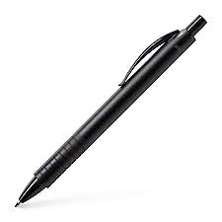NAME:-IGABE ALAIN BERTLAND DATE:11/03/2025

* UWIZEYIMANA

 ELISSA

DISCIPLINE

BRIGHT FUTURE ACADEMIC

COLLABORATION

INNOVATION

PREPARED BY -IGABE ALAIN BERTLAND CHECKED BY IRANZI THEONESTE

-UWIZEYIMAN ELISSA